User Guide for the Artifact Repository

By Colin Simon 20190387

# Accessing the repository

To access the repository first you need to change the directory to the folder that contains the repository, the dbproject folder by using **cd dbproject**

Next you enter the following command to start the server: **py manage.py runserver**

When the server starts running, enter the URL provided by command prompt and add /admin at the end of access to the repository where you will see the login screen.

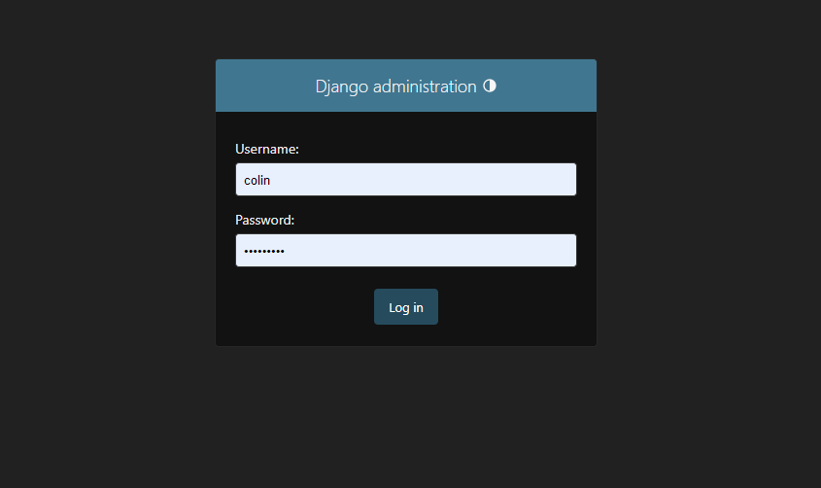

# The repository

Once you are logged in you should see the following page

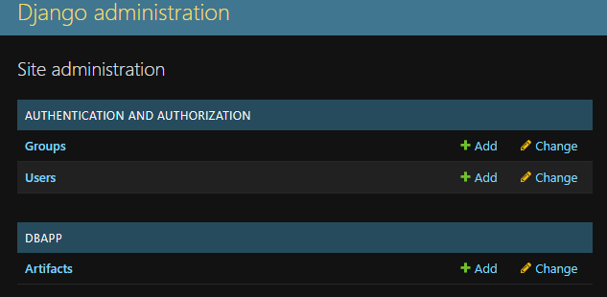

On this page you can access the repository by clicking on **Artifacts**

When you click on Artifacts you will be moved to the page that allows you to manipulate the repository

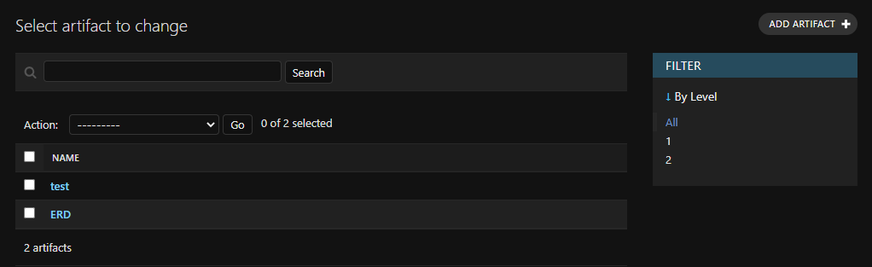

On this page you can: add, delete, search and filter the artifacts in the repository.

When adding an artifacts you are asked to enter fields for the following

